

**FPT UNIVERSITY**

**Taxi Caller Application on Windows Phone**

**F_Taxi**

**Report #6 – User’s Manual Document**

|  |  |
| --- | --- |
| F_Taxi | |
| Group Member | SE02705 - Phạm Gia Hữu |
| SE02900 - Tạ Thiên Hưởng |
| SE02268 - Phạm Ngọc Hoàn |
| SE02314 - Nguyễn Văn Lập |
| Supervisor | Nguyễn Văn Sang |
| Project Code | F_Taxi |

HaNoi, 12/2015

Table of Contents

1 INSTALLATION GUIDE 3

1.1 Purposes 3

1.2 Environments 3

1.3 Application Installation 3

2 USER's GUIDE 3

3 PROJECT RESULT REPORT 3

3.1 Product Judging 3

3.2 Project Summary 3

3.3 Lessons Learnt 3

# INSTALLATION GUIDE

## Purposes

This user’s manual has been developed to help users better understand the requirements that may apply to use this windows phone application by providing them simple step-by-step tutorials. This manual is intended to help making application functions more accessible and their associated requirements more understandable to users.

## Environments

* Visual Studio 2013:
  + Download on <https://www.visualstudio.com/downloads/download-visual-studio-vs> .
  + Install.
* Smart Phone with Windows Phone OS

# USER's GUIDE

## Guest

### First page

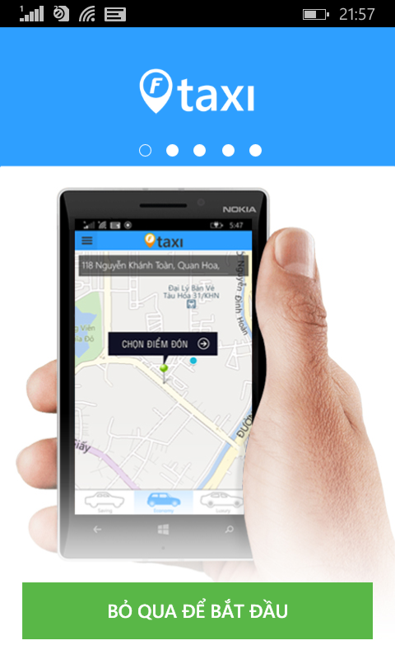

* Slide image on screen or tap on “Bỏ qua để bắt đầu” for move to Login page

### Create an account

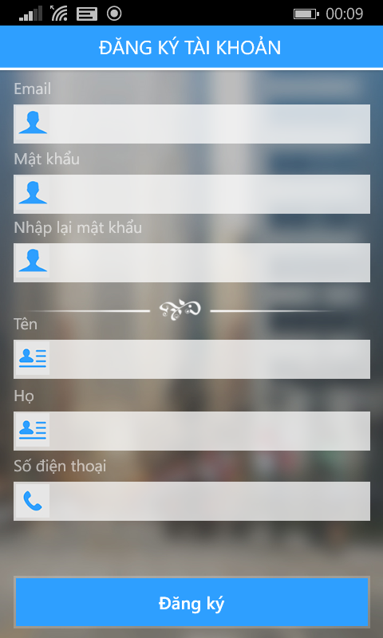

* Step 1 : Tap on “Đăng ký” button on screen
* Step 2 : Fill all information with right format.
* Step 3 : Tap on “Đăng ký” button for register. After that, your account will be ready to using F-Taxi.

## Rider

### Login to application

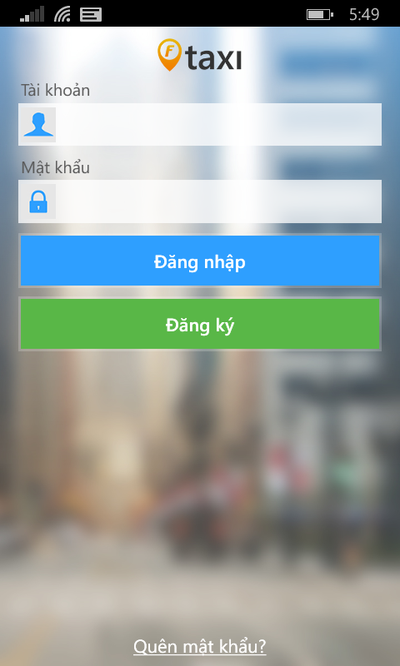

* Step 1: Fill your account on field.
* Step 2: Tap on “Đăng nhập” button.

### Take a taxi

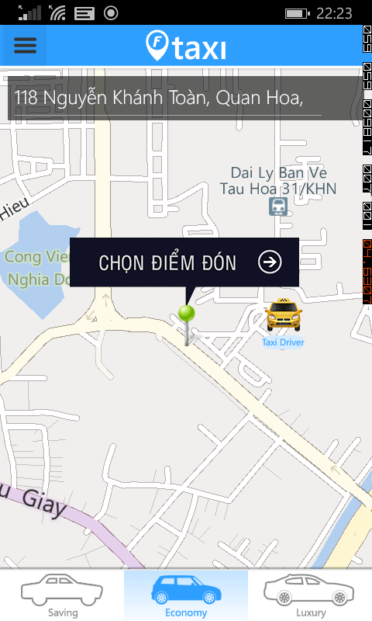

* Step 1: Using your finger to choose types of vehicle. There are up to three types of vehicle services for F-Taxi are: Saving, Economy, Luxury.
* Step 2: Mark your position on the map with a pin. This pin represents where the driver will be expecting to pick you up. You can also manually type in the pickup location on search bar. Once your location is set, tap on “Chọn điểm đón” button.

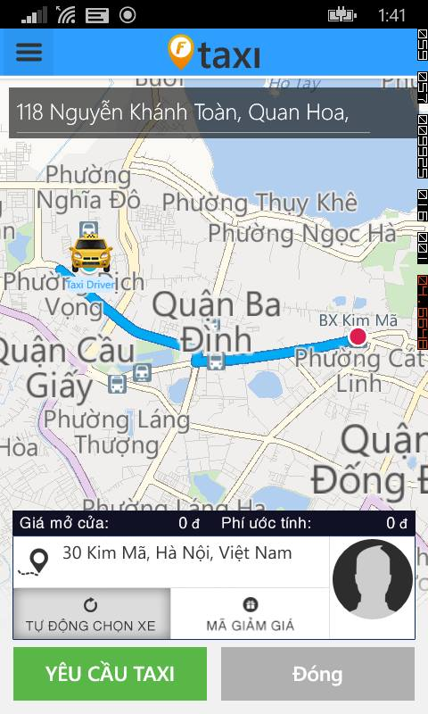

* Step 3: After tap on “Chọn điểm đón” button, show trip bar information. After, you can fill destination on line trip bar. If you have promotion code, tap on “Mã giảm giá”, F-Taxi will show the screen for you enter promotion code. Then, Tap on “Yêu cầu Taxi” button. (Tap on “Đóng” for new pick up address )

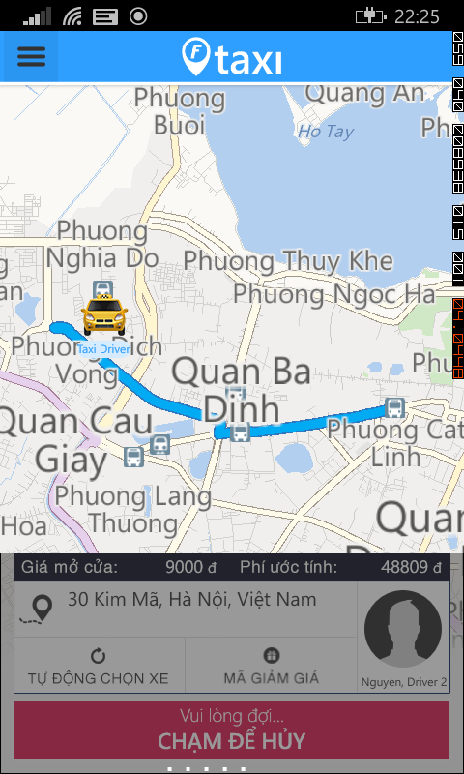

* Step 4: After tap on “Yêu cầu Taxi” button. Waiting Driver accept your request. You can tap on “Chạm để hủy” for cancel this request if you change your decision.

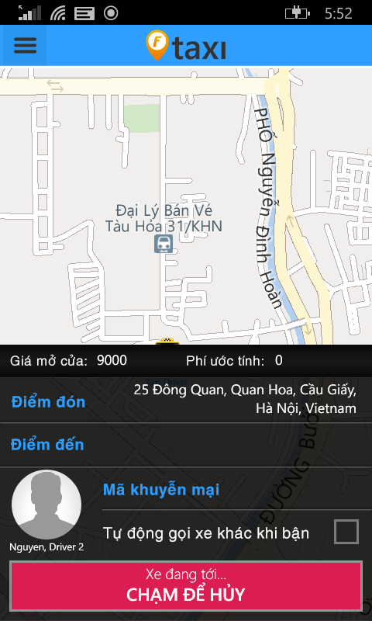

* Step 5: After Driver accept your request. You stand right your position and waiting car is coming.
* Step 6: Taxi driver pick you up and start a trip.
* Step 7: After finished a trip. Bill detail screen show up and pay your trip with cash. Tap on ”Đóng” button for back home page screen.

#### Call taxi center if no taxi around

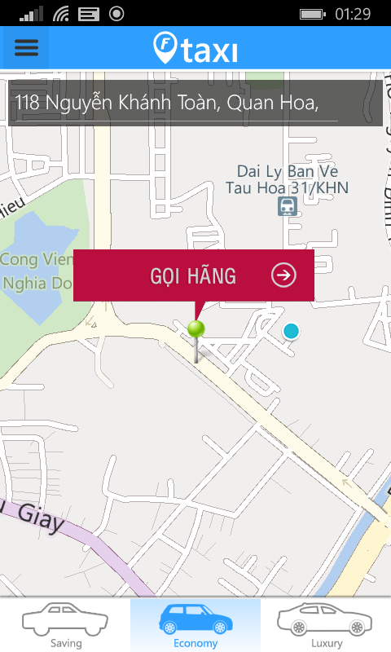

* Step 1: Tap on red “Gọi hãng” button for move to list taxi companies screen.

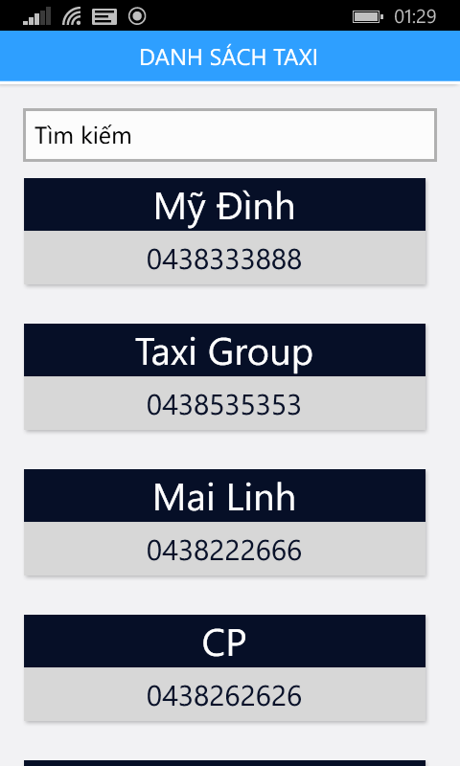

* Step 2: Tap on any taxi company for calling taxi center.
* Or enter character and tap on like :

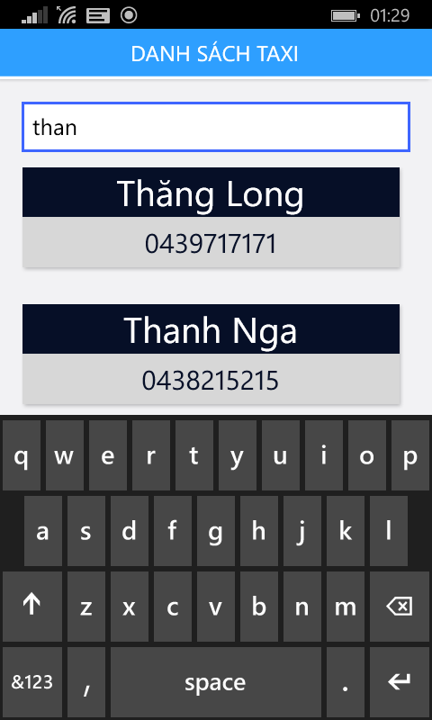

### Left Menu

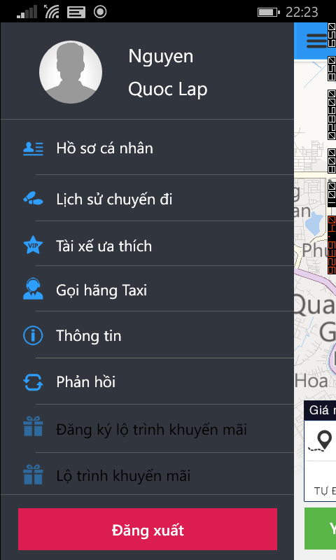

* You can tap on :
  + Avatar, Name or “Hồ sơ cá nhân” for view profile page screen.
  + “Lịch sử chuyến đi” for view history trip page screen.
  + “Tài xế ưa thích” for view favorite Driver page screen.
  + “Thông tin” for view application information.
  + “Phản hồi” for send feedback application.
  + “Đăng xuất” button for logout application.

#### Update Profile

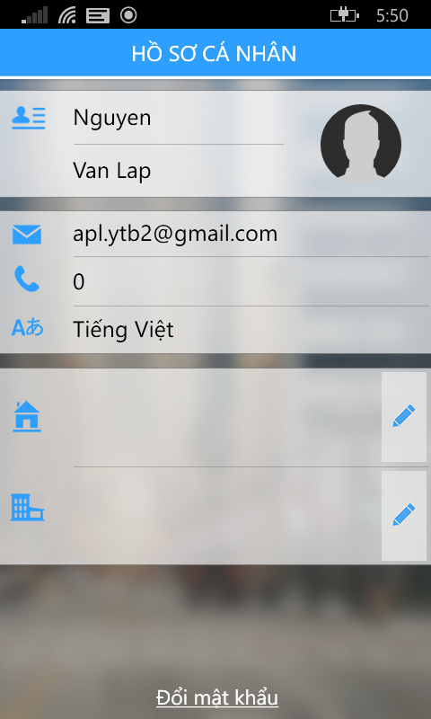

* Step 1: Tap on “Sửa” button on top right, and you enter new profile.

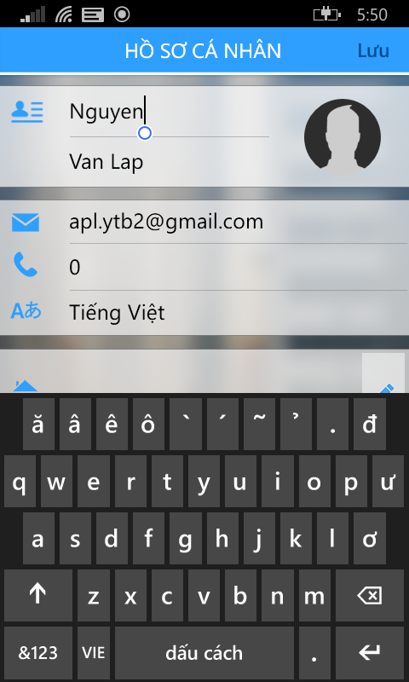

* Step 2: After enter all of change, tap on “Lưu” button for update profile.

**Update Address:**



* Step 1: Tap on pen icon , side by address for move to address page.

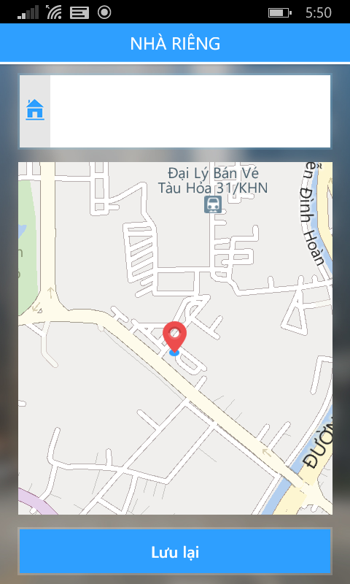

* Step 2: Enter your address and tap on “Lưu lại” button for update change address.

**Change Password:**



* Step 1: Tap on “Đổi mật khẩu” text for move change password page.

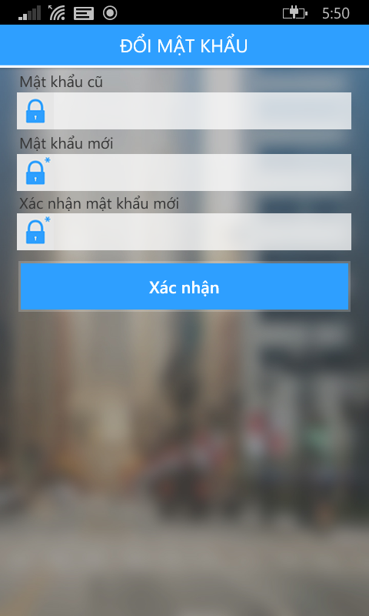

* Step 2: Fill all field and tap on “Xác nhận” button for change password.

#### View History Trip

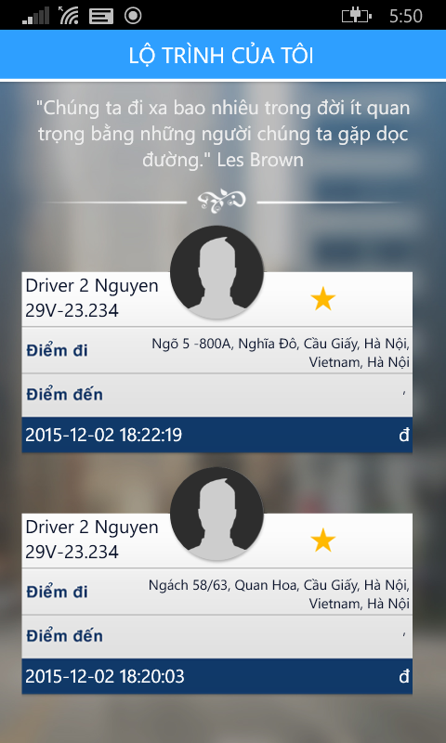

* Step 1: Tap on trip you want.

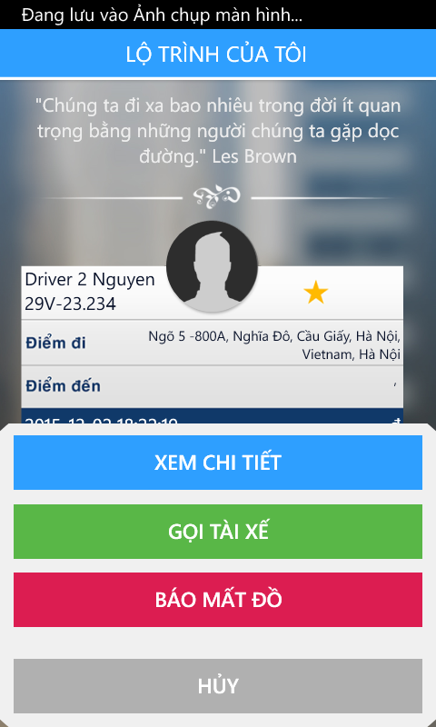

* Step 2: you can tap on :
  + Tap on “Xem chi tiết” button for view detail trip.
  + Tap on “Gọi tài xế” button for call taxi driver.
  + Tap on “Báo mất đồ” button for send notification lost asset.
  + Tap on “Hủy” button for back to view list history trip.

**Detail Trip**

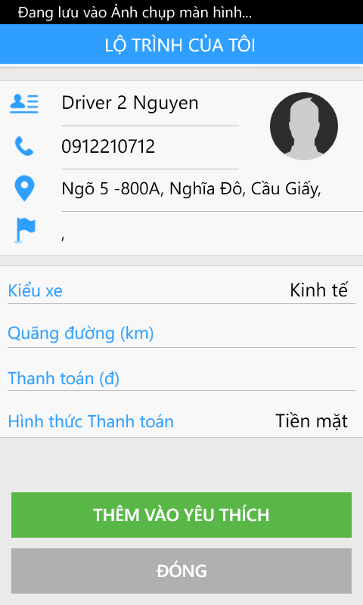

* View detail trip.
* Tap on “Thêm vào yêu thích” button for add favorite driver. Or tap on “Đóng” for close detail trip.

**Find Lost Asset**

* Fill all require field and tap on “Gửi” button.

#### View Favorite Driver

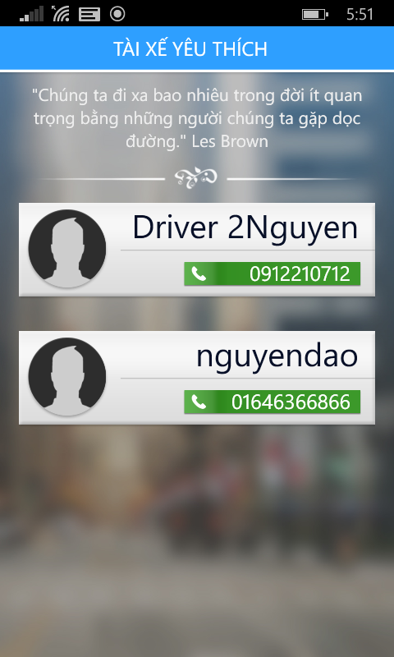

* Step 1: Tap on one of your Favorite Driver

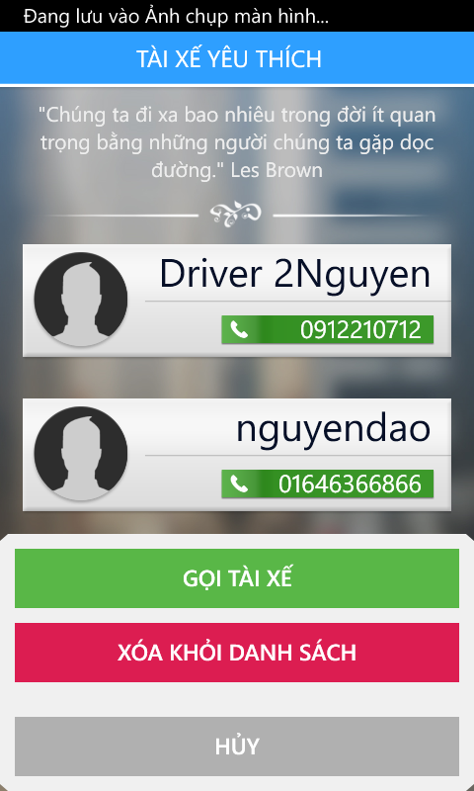

* Step 2: You can tap on :
  + “Gọi tài xế” button for calling driver instance.
  + “Xóa khỏi danh sách” button for delete favorite driver.
  + “Hủy” for back to list favorite driver.

#### Log out application



* Step 1: Tap on “Đăng xuất” button on menu bar.
* Step 2: Tap on “Có” button.

## Driver

### Login to application

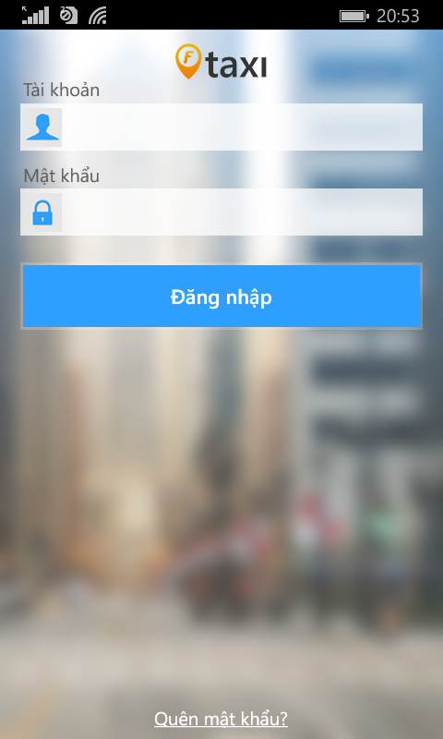

* Step 1: Fill your account on field.
* Step 2: Tap on “Đăng nhập” button.

### Change status

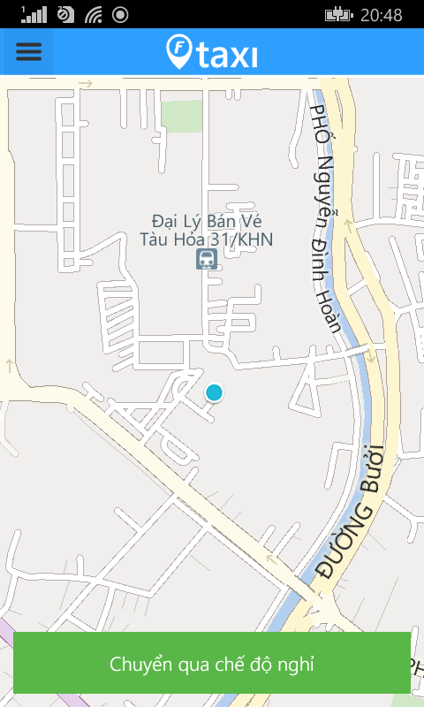

* Step 1: Tap on “Chuyển qua chế độ nghỉ” button.

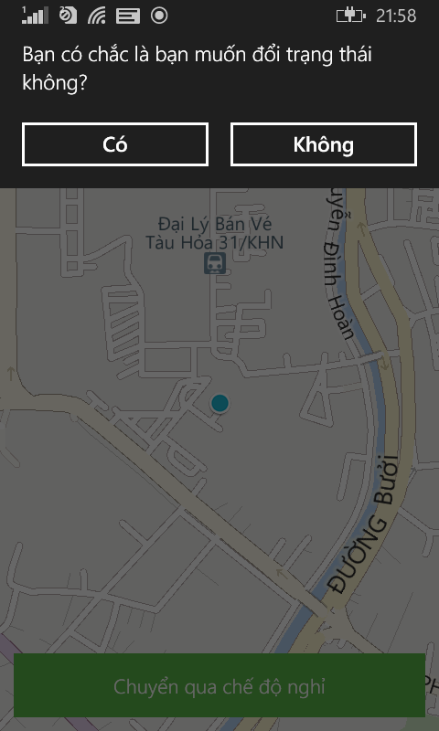

* Step 2: Tap on “Có” button.

### Take a trip with Customer request

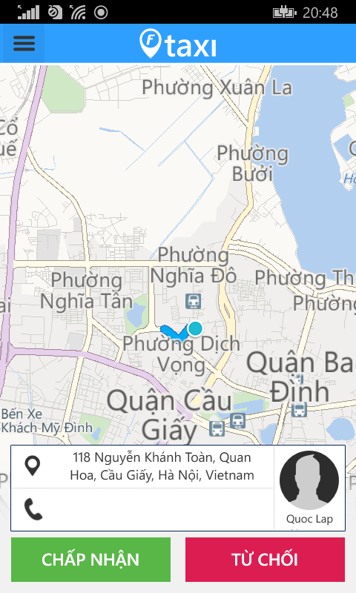

* Step 1: After received Customer request, tap on “Chấp nhận” button. And drive taxi to pick up address.

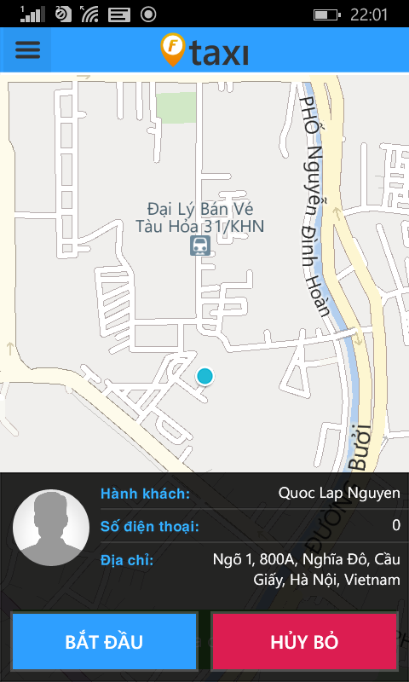

* Step 2: After pick up your customer. Tap on “Bắt đầu” button for start a trip

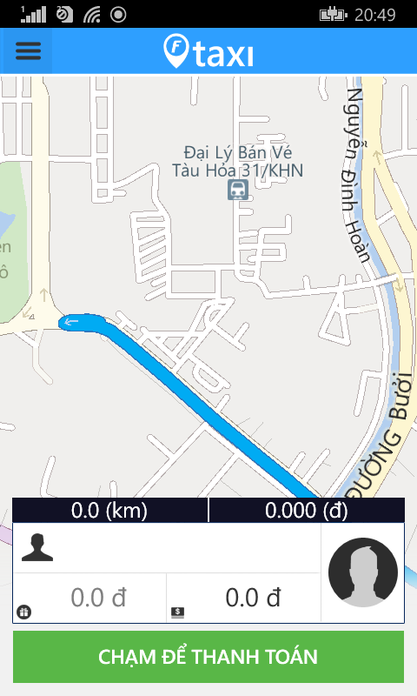

* Step 3: After finished trip. Tap on “Chạm để thanh toán” for show bill detail.

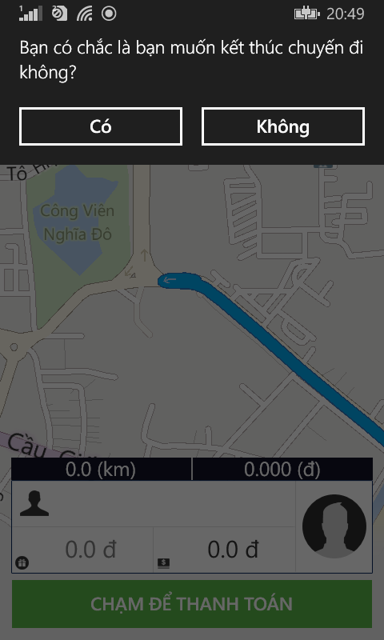

* F-Taxi will ask you want finished trip yes or not.

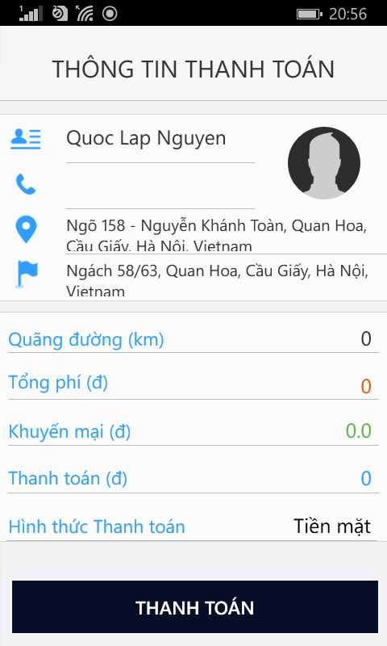

* Step 4: Receive cash from customer and tap on “Thanh toán” for end this trip.

### Left Menu

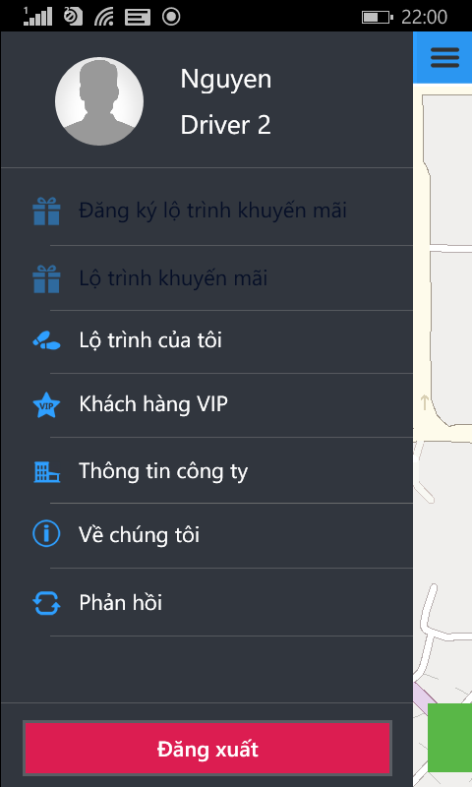

* You can tap on :
  + Avatar, Name or “Hồ sơ cá nhân” for view profile page screen.
  + “Lịch sử chuyến đi” for view history trip page screen.
  + “Thông tin công ty” for view company information.
  + “Về chúng tôi” for application information.
  + “Phản hồi” for send feedback application.
  + “Đăng xuất” button for logout application.

#### Update Profile



* Step 1: Tap on “Sửa” button on top right, and you enter new profile.



* Step 2: After enter all of change, tap on “Lưu” button for update profile.

**Update Address:**



* Step 1: Tap on pen icon , side by address for move to address page.



* Step 2: Enter your address and tap on “Lưu lại” button for update change address.

**Change Password:**



* Step 1: Tap on “Đổi mật khẩu” text for move change password page.



* Step 2: Fill all field and tap on “Xác nhận” button for change password.

#### View Company Information

#### View History Trip



* Step 1: Tap on trip you want.



* Step 2: you can tap on :
  + Tap on “Xem chi tiết” button for view detail trip.
  + Tap on “Gọi tài xế” button for call taxi driver.
  + Tap on “Báo mất đồ” button for send notification lost asset.
  + Tap on “Hủy” button for back to view list history trip.

**Detail Trip**



* View detail trip.
* Tap on “Thêm vào yêu thích” button for add favorite driver. Or tap on “Đóng” for close detail trip.

**Find Lost Asset**

* Fill all require field and tap on “Gửi” button.

#### Log out application



* Step 1: Tap on “Đăng xuất” button on menu bar.
* Step 2: Tap on “Có” button.

# PROJECT RESULT REPORT

## Product Judging

## Project Summary

## Lessons Learnt